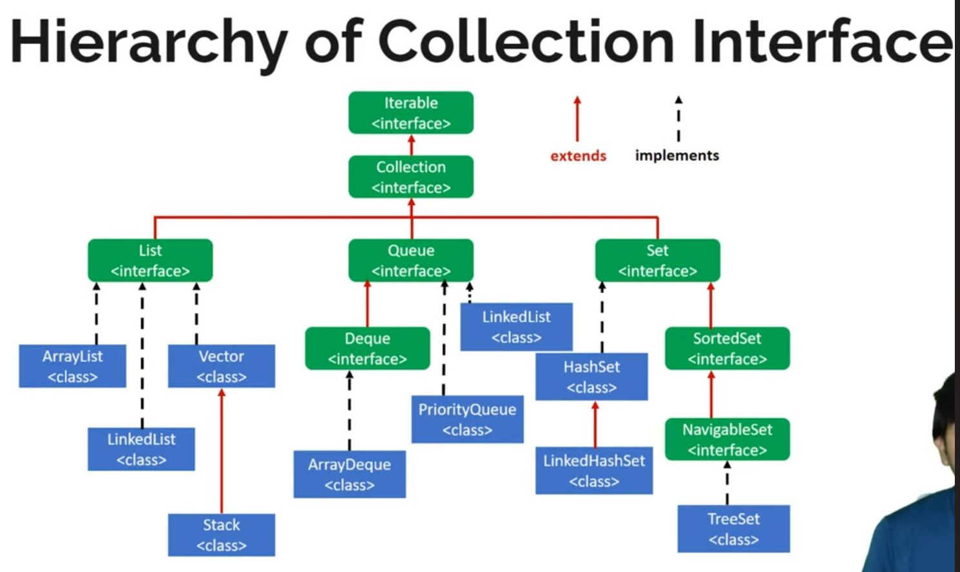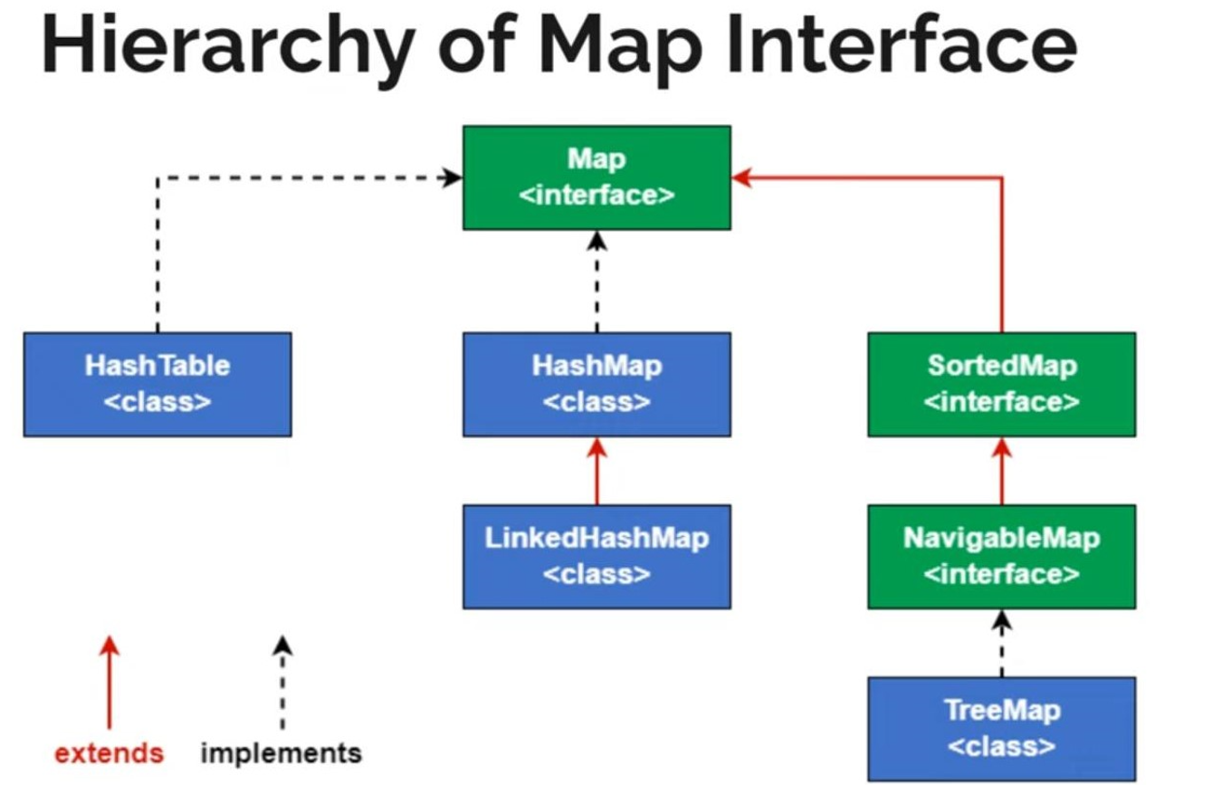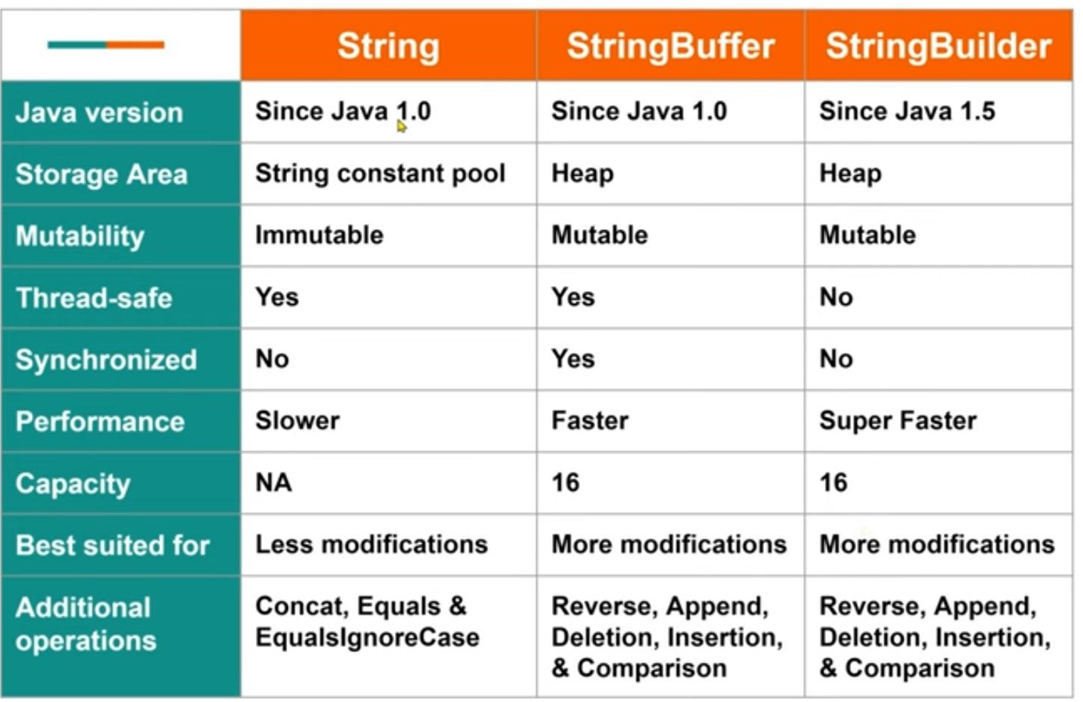
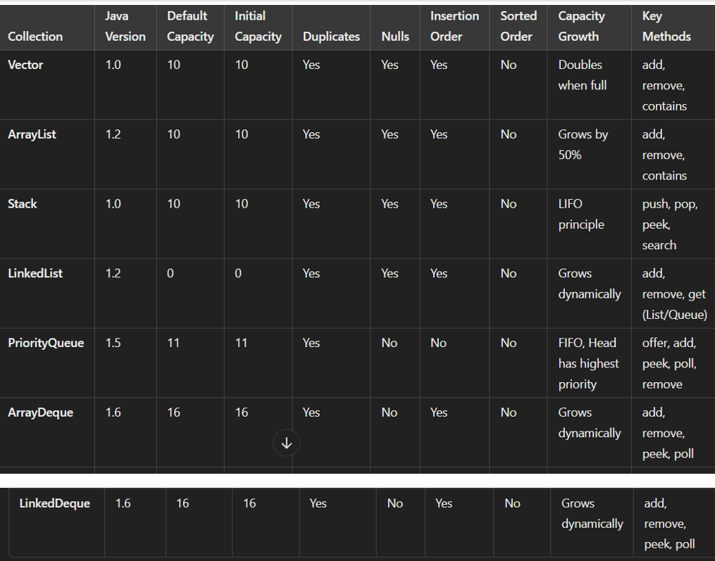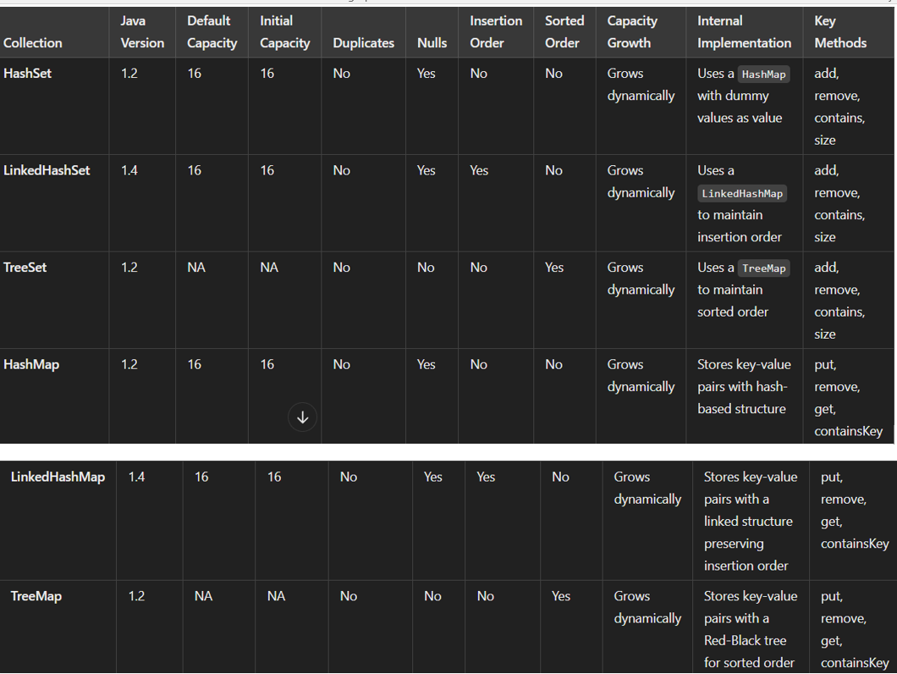
VECTOR{ After 10 size 100% peruguthundi} Array List{ After 10 size sagame peruguthundi } Stack :{ LIFO Principal} Linked List :{ LIST & Queue rendu Extend } ex: Train bogi , Total List lo starting and Ending Null values vuntayy{ Previous& Next} , Element ni get chesetappudu Total size / 2 = target Index 10/2 target index 4 – > 5>4 avithe left side or 5<4 avithe Right side ki velthundi , List implementation Object ni base chesukoni vuntadi
Priority Queue : {FIFO, ex : Hospital que}Head – high important , Tail – insertArray deque :head high values anedi NO, insertion order : Yes} Priority Queue {Head – delete & Tail – insert } Array Deque : {Head – inser/delete & Tail – insert/delete set anedi inter nal ga Mpas ni use chesukuntadi , set lo values ni update cheyatam ante deleate cheyatame, (key, value gane store avuthundi, value palce dummy object vuntundi
